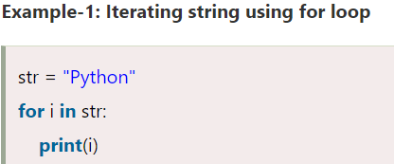

**OUTPUT:** PYTHON

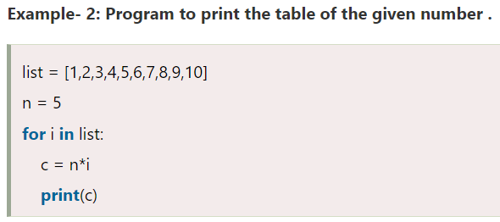

**OUTPUT:** 5 10 15 20 25 30 35 40 45 50

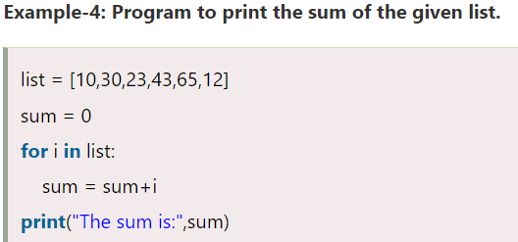

**OUTPUT:** The sum is:183

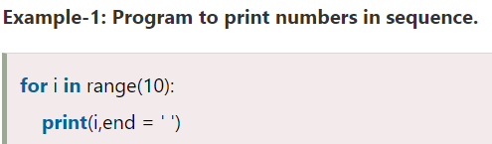

**OUTPUT:** 0 1 2 3 4 5 6 7 8 9

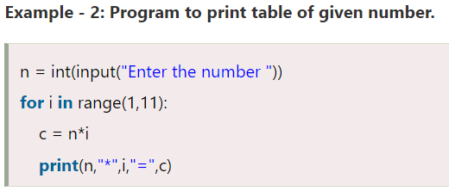

**OUTPUT:** enter the number 5

5 * 1 = 5

5 * 2 = 10

5 * 3 = 15

5 * 4 = 20

5 * 5 = 25

5 * 6 = 30

5 * 7 = 35

5 * 8 = 40

5 * 9 = 45

5 * 10 = 50



**OUTPUT:** hello peter

hello joseph

hello ricky

hello devansh

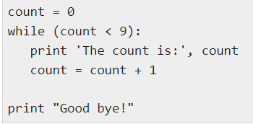

**OUTPUT:** the count is: 0

the count is: 1

the count is: 2

the count is: 3

the count is: 4

the count is: 5

the count is: 6

the count is: 7

the count is: 8

good bye!

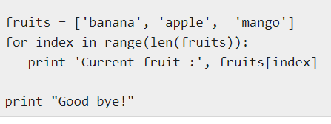

**OUTPUT:** current fruits: banana

current fruits: apple

current fruits: mango

good bye!

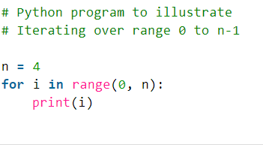

**OUTPUT:** 0 1 2 3

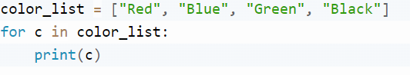

**OUTPUT:** red blue green black

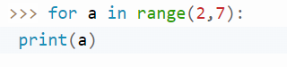

**OUTPUT:** 2 3 4 5 6

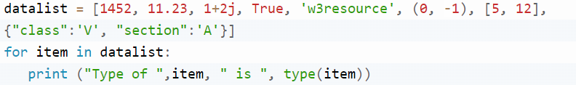

**OUTPUT:** type of 1452 is <class 'int'>

type of 11.23 is <class 'float'>

type of (1+2j) is <class 'complex'>

type of True is <class 'bool'>

type of w3resourse is <class 'str'>

type of (0, -1) is <class 'tuple'>

type of [5, 12] is <class 'list'>

type of {'class': 'V', 'section': 'A'} is <class 'dict'>

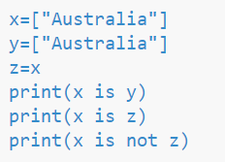

**OUTPUT:** False True False